Technical / Functional Design Specifications

Project Name: Artificially Intelligent Grid Assistant (A.I.G.A)

Title: Object Title (match to Gap)
Object ID: DR#
Program: Program ID
Module: SAP Module

Review Date:
Reviewers:

Technology used:

- .NET Framework 2.0
- .NET Framework 2.0 based Alchemi toolkit library for construction of Grid architecture
- Ms Conference XP (A Microsoft Research Initiative) framework
- Visual Studio Express Edition 2005
- BizTalk
- AIMLBot Class in C# (www.aimlbot.sourceforge.net)
- Microsoft SQL Server 2005
- Microsoft IIS Server Version 5.1
- ASP.NET 2.0, ASP.NET Web Services
- Smart Device Client Application
    - Application Interface built for Windows CE 5.0 or later.

Databases Used:
Microsoft SQL Server 2005
AIML (Artificially Intelligent Markup Language), (www.aimlbot.sourceforge.net)
Creation Date:
15th September, 2007

Review Date:
10th November, 2007

Reviewers:
Mangesh Bedekar (BITS, Pilani Goa)
Bharat Deshpande (BITS, Pilani Goa)
Vishal Kailash Bansal (CSC, India)

Table Of Contents

Program Heading 3
Revision Section 3
Data Flow Diagram 4
E-R Diagram 7
Functionality / Features of Project 10
Final Output of the project 16
Additional Information/Attachments 16

Program Heading

Program Information

Program Name | Language / Technology | Database | Hardware | Prepared on | Reviewed on
AIGA | C#, .NET Framework 2.x | SQL/AIML | WIN XP/98,Dual core | 15th September | 15th November

Revision Section

Revision# | Program | Date | Author | Section(s) Affected | Description

1.0 | AIGA | 15th Sep | Shubham Malhotra | Data Flow | Use Cases Affected

Data Flow Diagram

Brief Introduction to the Project:

AIGA – a complete Grid infrastructure as its backbone (“world”) can be used to gather this disseminated knowledge. Specialized intelligent bots (“technology drives education”) trained using the free computation cycles (“education is free”) of the Grid and backed with knowledge of all the experts and researchers (“interesting and unifying”) from diversified fields will be ready to answer any question.

Generic Topology of System

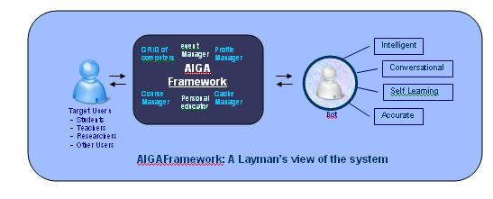

ARCHITECTURE DIAGRAM

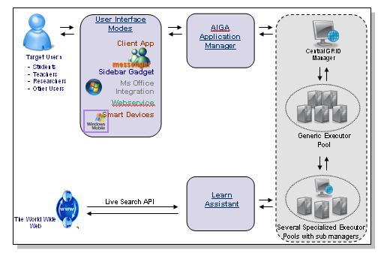

Components of AIGA:
The Web service

The AIGA web service is responsible for authentication and serves as a broker between client Applications and the central Application Manager of AIGA. In some sense, it acts as the middleware between client and the “real” server – i.e. the Central Manager of the GRID Framework.
User Interface/Client:

This is the primary mode of interaction for the user. We have built several different user interfaces for interaction with the user:

- A Client Application for students. Provides an easy to use interface with the bot as well as add-on tools such as calendar and schedule.
- An interface designed and implemented as a user/friend within Windows Live Messenger.
- We are still working on integration of the AIGA framework and the bot within ConferenceXP and as an IE7 add-on.
- The web based interface provides features that enable the bot to link itself to other websites.

Central Application Manager and the GRID Framework:

One of the most important components of our project
- This is the backbone of AIGA and supports the bots.

Profile Manager
- Used for managing profile of users and personalization of information.

Event Manager
- Used for managing events such as workshops and online learning sessions organized by professors/teachers.

Learn Assistant
- AIGA makes use of Microsoft Live Search API in order to obtain latest and accurate information on frequently asked topics from the World Wide Web.

The intelligent Bot based on AIML
- This is the “brain” of our project.

Data Flow Diagram






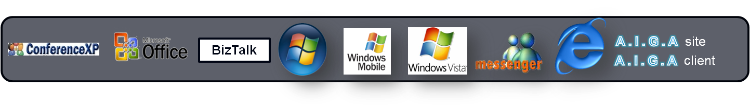
Generic Executor Pool
Specialized Executor Pool

User
Manager

E-R Diagram

Executor Architecture

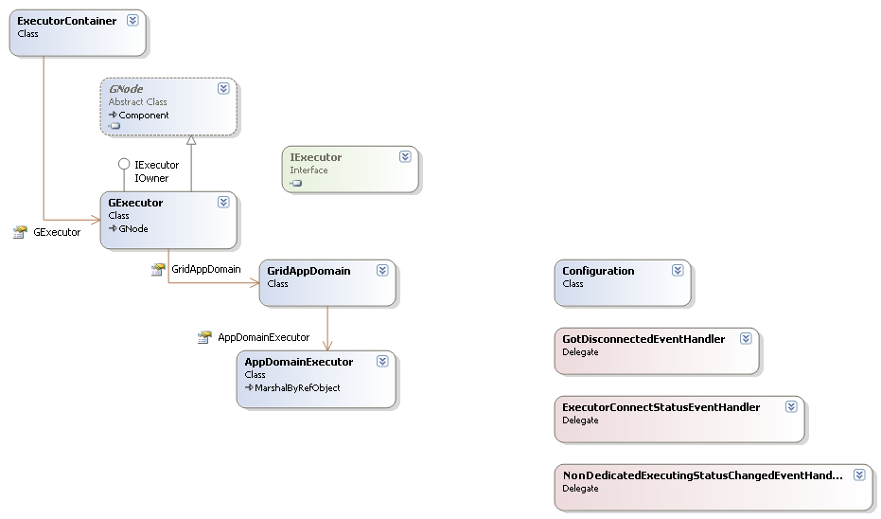
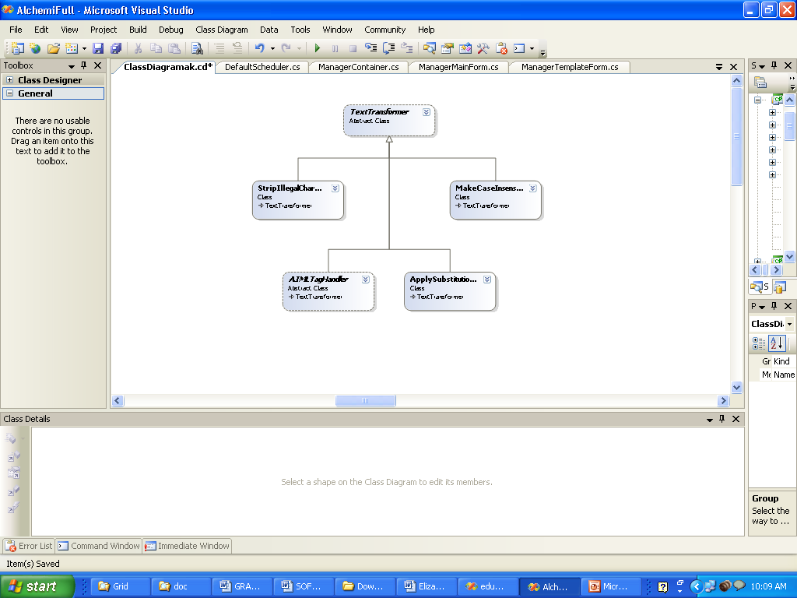

Cache
The GRID Thread Executor
The AIML Bot Class
INSIDE AN EXECUTOR NODE

Manager Architecture

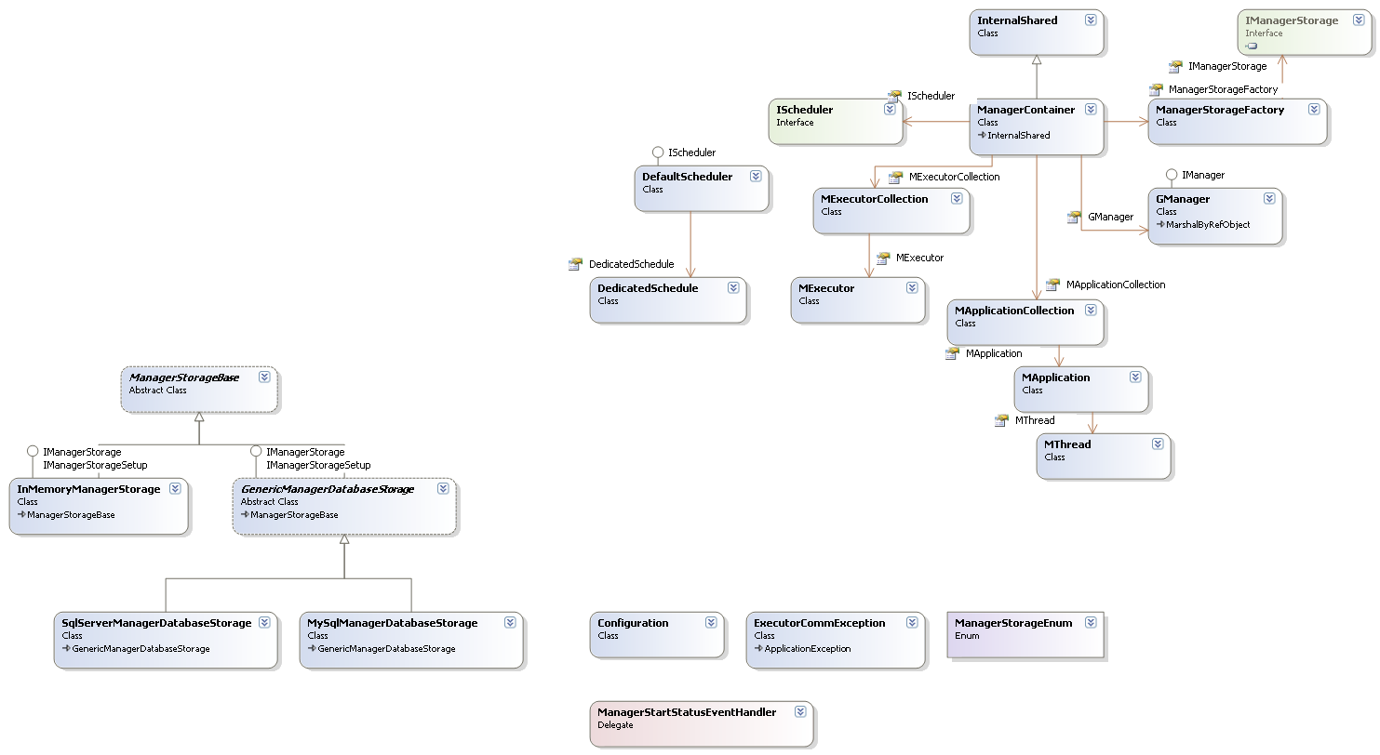
The GRID Manager
The Scheduler
INSIDE A MANAGER NODE
Other Managers of further GRID pools which are of higher specialization level

Grid Application Architecture - General

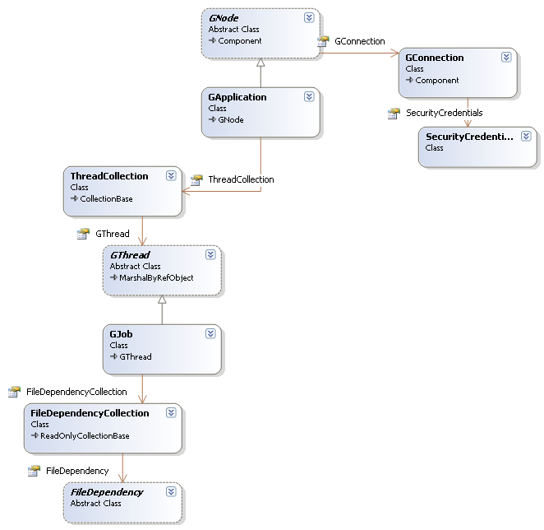

Functionality / Features of Project

BRIEF DESCRIPTION OF WORKING

The GRID framework

Introduction to GRIDs
- The idea of meta-computing - the use of a network of many independent computers as if they were one large parallel machine, or virtual supercomputer - is very compelling since it enables supercomputer-scale processing power to be had at a fraction of the cost of traditional supercomputers.
- While traditional virtual machines (e.g. clusters) have been designed for a small number of tightly coupled homogeneous resources, the exponential growth in Internet connectivity allows this concept to be applied on a much larger scale.
- This, coupled with the fact that desktop PCs in corporate and home environments are heavily underutilized – typically only one-tenth of processing power is used – has given rise to interest in harnessing the vast amounts of processing power that is available in the form of spare CPU cycles on Internet- or intranet-connected desktops.
- This new paradigm has been dubbed Grid Computing.

How Alchemi Works

Alchemi is a .NET grid computing framework that allows us to painlessly aggregate the computing power of intranet and Internet-connected machines into a virtual supercomputer (computational grid) and to develop applications to run on the grid.

There are four types of distributed components (nodes) involved in the construction of Alchemi grids and execution of grid applications: Manager, Executor, User and Cross-Platform Manager.

Broad Overview of Alchemi Grid
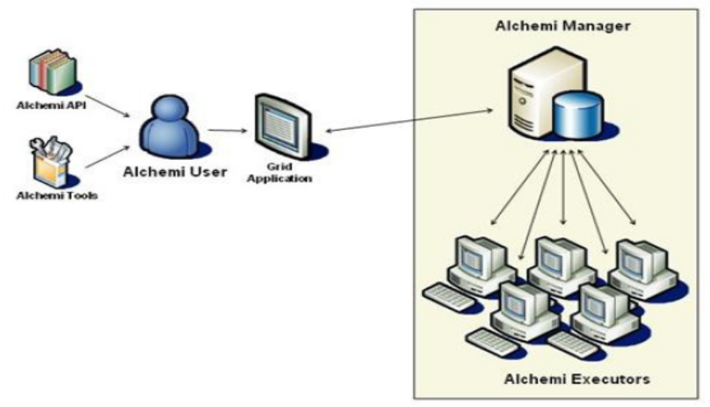
Why we chose Alchemi

The Alchemi grid computing framework was conceived with the aim of making grid construction and development of grid software as easy as possible without sacrificing flexibility, scalability, reliability and extensibility. The key features supported by Alchemi are:
- Internet-based clustering of desktop computers without a shared file system
- Federation of clusters to create hierarchical, cooperative grids
- Dedicated or non-dedicated (voluntary) execution by clusters and individual nodes
- Object-oriented grid thread programming model (fine-grained abstraction)
- Web services interface supporting a grid job model (coarse-grained abstraction) for cross-platform interoperability e.g. for creating a global and cross-platform grid environment via a custom resource broker component
- An Open source project and easily modifiable source. We have made heavy modifications to the scheduling mechanism of the manager and have integrated the bot into a separate AppDomain within the Executor

Our GRID framework

We have used the Alchemi Framework to construct the grid framework to be used by our bots.
- The central Application manager is responsible for interacting with a cluster of executors at the first level – called the generic execution pool because they host the aiml files for the General Knowledge KB. The bots hosted on this cluster can reply to a variety of topics without going into detail. In general, these bots would reply to queries assuming that a layman is asking them. In case it does not find an answer, it will forward the query to the specialized GRID on basis of a periodically updated index.
- After the Central Manager comes the generic execution pool, which also has a manager and various executors. A load balancing algorithm is used to effectively utilize the GRID.
- In case the user is an expert in his field, or the query is not answerable by the generic bots, they are forwarded to specialized bots that are searched using a scheduling algorithm to make use of the parallel computation power of the grid.

Working of the Intelligent Bot
Imagine that you can talk with your computer in natural language and she understands what you say. We are not referring to voice activated word processors. Goal is something like Mr. DATA in star trek.
Imagine a talk with a complicated database system and getting results instead of writing SQL code.
Applications of a natural language-processing program that can do logical reasoning are unlimited. This project is a step in this direction.

Brief Overview of System
This system is an artificial intelligence entity, with the power of NLP, as a virtual teacher for learning and assessment available for student use.
It has a logical reasoning engine and uses two knowledge bases, one for statistical inference and the other for rules of English grammar and general knowledge to facilitate learning. It provides lessons in inferential statistics.
The user can ask questions in English and have a dialogue with virtual teacher. It searches its knowledge bases (KB), uses its first order predicate logic reasoning engine and converses with the student using its Natural Language Processing (NLP) sub-system. It is aimed to provide a multimedia experience.

STUDENT
What is …?
What do you mean by…?
Answer is …
INPUT/OUTPUT INTERFACES

Text
Voice
Logical
Reasoning
Module
Natural Language
Processing
Module

General Knowledge KB
Subject Specific KB
User Profile
Schematic Diagram of Bot Design

The Data Storage Mechanism
The AIGA bot uses an AIML interpreter to extract data from AIML files. AIML is the abbreviation for Artificial Intelligence Markup Language. It is an easy to use XML type language for communicating with and teaching the bot.
The AIML database contains 3 types of information
- General Knowledge KB
This Knowledge Base is used to store general information regarding various topics and is mainly used for intelligent conversation with the user. Currently, our bot has about 31,000 categories in its general knowledge Base.
- Subject Specific KB
This stores information regarding specific fields EG Healthcare, Archaeology etc… It is mainly hosted within the specialized execution pool and its services are called for only when the general execution pool (General bots) is unable to find a suitable reply to the user query.
- User Profile KB
This is used to store personalized user information. For e.g. the health profile of a user, personal information like telephone number etc…
<? xml version="1.0" encoding="ISO-8859-1"?>
<aiml>
<category><pattern>THE JRES *</pattern><template>I'm not an expert on JRE's.</template></category>

<category><pattern>JAVA *</pattern><template>You can download the latest Java release from <a target="_new" href="http://java.sun.com">java.sun.com</a>.</template></category>

<category><pattern>A JAVA *</pattern><template>Developments in Java interest me greatly.</template></category>

<category><pattern>WHAT ARE DEPRECATED *</pattern><template> <br/> One of the biggest challenges facing a Java application<br/> developer is finding a "lowest common denominator" subset of the<br/> Java language that works on all the platforms and versions<br/> out there. The Java language itself is a moving target.<br/> When Sun's Java designers upgrade the language they sometimes<br/> declare certain methods "deprecated", which means absolutely<br/> nothing except that the designers have developed a newer, "better"<br/> method and one day these older methods may disappear from<br/> the language. Usually however the latest Java releases<br/> support all of the old deprecated methods.<br/> <br/> </template></category>
<category><pattern>A WEB SITE</pattern><template>Can you give me the specific URL?</template></category>
ONE OF THE AIML FILES: Demonstration of Storage mechanism in xml based aiml

Personalization of Bots as per different aspects of users

- In addition to having a general bot for user queries, AIGA will also have bots which are personalized and specialized on specific basis.
- For e.g. a variant of the AIGA bot could be specialized in health-care and personalized to a particular user (Say Mr. A. who has diabetes). In this case, all health related questions asked to this bot would be replied to in context of a diabetic patient.
- Similarly other bots could be trained in different functionality and could be as useful as a ready intelligent encyclopedia or as innovative as a schedule planner.
- Based on the training provided, the bots could be specialized in a variety of different and diverse fields to assist personnel in a variety of different jobs. For e.g. an archaeologist could be provided with a bot specialized in archeology and history.
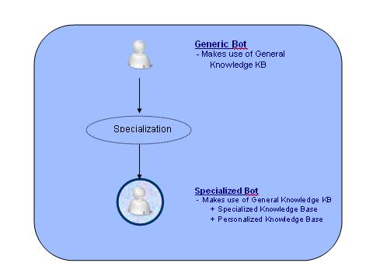

Final Output of the project

Different Interfaces provide different features in addition to the simple question answering system.

1. Client Interface
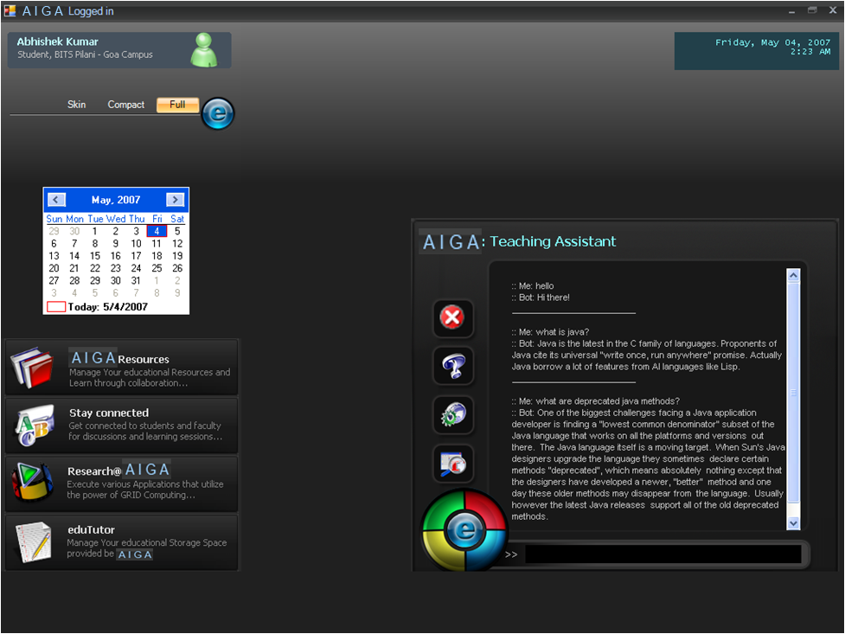
1. The Client interface: .NET based client that gives a very user friendly interface to ask queries to the Assistant and more additional features.
.

Input: Hello
Output: Hi there!

Input: What is Java?
Output: Java is the latest in the C family of languages. Proponents of Java cite its universal "write once, run anywhere" promise. Actually Java borrows a lot of features from AI languages like Lisp.

Input: What is Windows?
Output: Windows is a line of graphical operating systems used on personal computers made by Microsoft

2. Web Interface

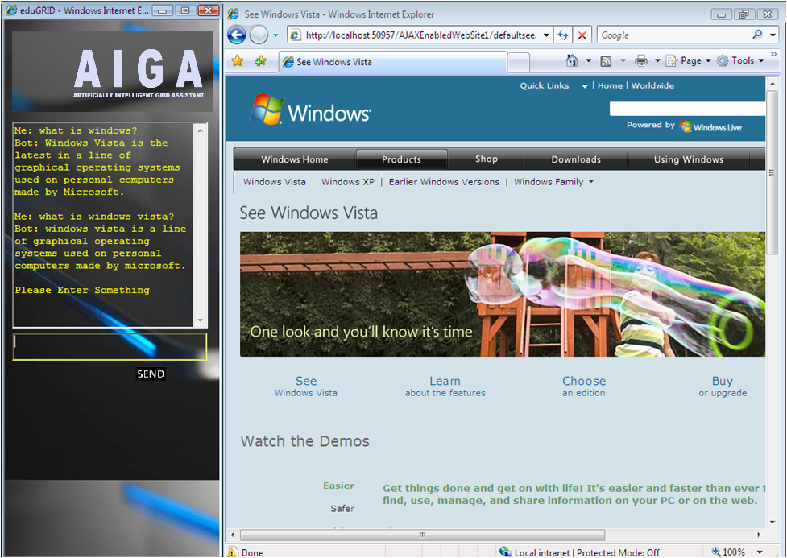
2. The Web interface: Intelligently opens the Web page that is most related to the current query

3. Mobile Interface

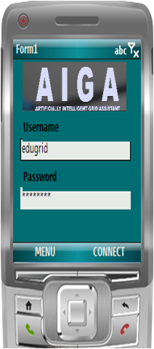
user
user
3. The Mobile Interface: Giving Connectivity to A.I.G.A from anywhere

Additional Information/Attachments

TWO IMPORTANT FUNCTIONS

Function #1: Grid Thread Execution in Application Domain (@Executor)

private void ExecuteThreadInAppDomain()
{
byte[] rawThread = null;
try
{
logger.Info("Started ExecuteThreadInAppDomain...");
logger.Info(string.Format("executing grid thread # {0}.{1}",
_CurTi.ApplicationId, _CurTi.ThreadId));
string appDir = GetApplicationDirectory(_CurTi.ApplicationId);
logger.Debug("AppDir on executor=" + appDir);
if (!_GridAppDomains.Contains(_CurTi.ApplicationId))
{
lock(_GridAppDomains)
{
// make sure that by the time the lock was acquired
//the app domain is still not created
if (!_GridAppDomains.Contains(_CurTi.ApplicationId))
{
// create application domain for newly encountered
//grid application
logger.Debug("app dir on executor: " + appDir);
//before initializing clear dir..
foreach (string F in Directory.GetFiles(appDir))
{
try //becoz exception should not be created
//for an issue as small as this
{
File.Delete(F);
}
catch (Exception ex)
{}
}
FileDependencyCollection manifest =
Manager.Executor_GetApplicationManifest(Credentials,
_CurTi.ApplicationId);
if (manifest != null)
{
foreach (FileDependency dep in manifest)
{
try //so that IO error doesnt occur if files
//already exist
{
logger.Debug("Unpacking file: " + dep.FileName +
" to " + appDir);
dep.UnPackToFolder(appDir);
}
catch (Exception ex)
{}
}
}
else
{
logger.Warn("Executor_GetApplicationManifest from the
Manager returned null");
}
--→ continued on next page…

--→ continued from previous page…

initialize_GridThreadExecutor();

_GridAppDomains.Add(
_CurTi.ApplicationId,
New GridAppDomain(GridThreadApplicationDomain,
GridThreadExecutor)
);

logger.Info("Created app domain, policy, got instance of
GridAppDomain and added to hashtable...all done
once for this application");
}
else
{
logger.Info("I got the lock but this app domain is already
created.");
}
}

//get thread from manager
GridAppDomain gad =
(GridAppDomain) _GridAppDomains[_CurTi.ApplicationId];

rawThread = Manager.Executor_GetThread(Credentials, _CurTi);
logger.Debug("Got thread from manager. executing it:
"+_CurTi.ThreadId);

//execute it

byte[] finishedThread = gad.Executor.ExecuteThread(rawThread);
logger.Info(string.Format("ExecuteThread returned for thread #
{0}.{1}", _CurTi.ApplicationId, _CurTi.ThreadId));

//set its status to finished
Manager.Executor_SetFinishedThread(Credentials, _CurTi,
finishedThread, null);
logger.Info(string.Format("Finished executing grid thread #
{0}.{1}", _CurTi.ApplicationId, _CurTi.ThreadId));
}
catch (ThreadAbortException)
{
if (_CurTi!=null)
logger.Warn(string.Format("aborted grid thread # {0}.{1}",
_CurTi.ApplicationId, _CurTi.ThreadId));
else
logger.Warn(string.Format("aborted grid thread #
{0}.{1}",null, null));
Thread.ResetAbort();
}

--→ continued on next page…

--→ continued from previous page…

catch (Exception e)
{
logger.Warn(string.Format("grid thread # {0}.{1} failed ({2})",
_CurTi.ApplicationId, _CurTi.ThreadId, e.GetType()),e);
try
{
//some exceptions such as Win32Exception caused problems when
passed directly into this method.
//so better create another new exception object and send it over.
Exception eNew = new Exception(e.ToString());
Manager.Executor_SetFinishedThread(Credentials, _CurTi,
rawThread, eNew);
}
catch (Exception ex1)
{
if (_CurTi!=null)
{
logger.Warn("Error trying to set failed thread for App:
"+_CurTi.ApplicationId+", thread="+_CurTi.ThreadId + ".
Original Exception = \n" + e.ToString(),ex1);
}
else
{
logger.Warn("Error trying to set failed thread: Original
exception = " + e.ToString(), ex1);
}
}
}
finally
{
_CurTi = null;
_ReadyToExecute.Set();
logger.Info("Exited ExecuteThreadInAppDomain...");
}
}

Function #2: The AIML chat Function

public Result Chat(Request request)
{
Result result = new Result(request.user, this, request);
if (this.isAcceptingUserInput)
{
// Normalize the input
AIMLLoader loader = new AIMLLoader(this);
AIMLbot.Normalize.SplitIntoSentences splitter = new
AIMLbot.Normalize.SplitIntoSentences(this);
string[] rawSentences = splitter.Transform(request.rawInput);
foreach (string sentence in rawSentences)
{
result.InputSentences.Add(sentence);
string path = loader.generatePath(sentence,
request.user.getLastBotOutput(), request.user.Topic,
true);
result.NormalizedPaths.Add(path);
}
// grab the templates for the various sentences from the graphmaster
foreach (string path in result.NormalizedPaths)
{
Utils.SubQuery query = new SubQuery(path);
query.Template = this.Graphmaster.evaluate(path, query,
request, MatchState.UserInput, new StringBuilder());
result.SubQueries.Add(query);
}
// process the templates into appropriate output
foreach (SubQuery query in result.SubQueries)
{
if (query.Template.Length > 0)
{
try
{
XmlNode templateNode =
AIMLTagHandler.getNode(query.Template);
string outputSentence =
this.processNode(templateNode, query, request,
result, request.user);
if (outputSentence.Length > 0)
{
result.OutputSentences.Add(outputSentence);
}
}

catch (Exception e)
{
if (this.WillCallHome)
{
this.phoneHome(e.Message, request);
}
this.writeToLog("WARNING! A problem was encountered
when trying to process the input: " +
request.rawInput + " with the template: \"" +
query.Template + "\"");
}
}
}
}
else
{
result.OutputSentences.Add(this.NotAcceptingUserInputMessage);
}
// populate the Result object
result.Duration = DateTime.Now - request.StartedOn;
request.user.addResult(result);
return result;
}

--→ End of code section ←--

